Laura Richardson Unit 1 Lab and Challenge
- .ma file — committed and pushed to GitHub via GitDesktop
  - https://github.com/richar65/Essentials/blob/main/DAGV1100and1200/Maya/scenes/Unit%201%20Scene%20LR%20Day%202.ma
- Screenshot of your Perspective view uploaded to Canvas
  - 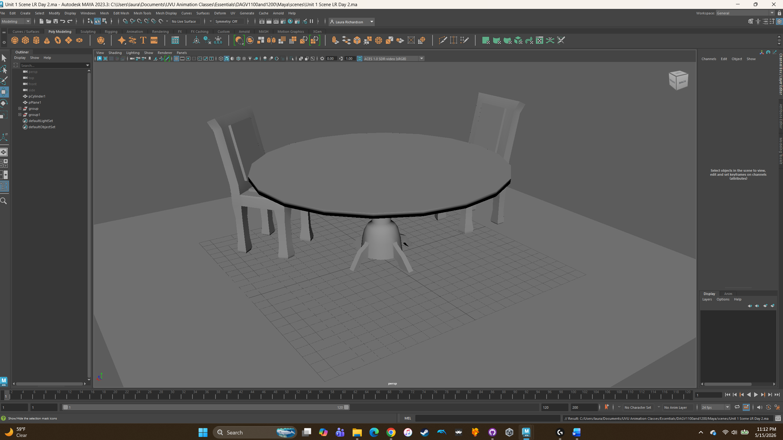
- 100-word reflection (briefly describe your workflow and a creative twist)
  - I wanted to just play around with the suggested design techniques, but I also added in edge loop tool. With the table, I wanted most of it to be round, so I could play with scaling edges. The legs at the bottom, I extruded the faces of area down below. For the legs I rotated some of the stuff and added more edge loops. For the floor it is a simple plane snapped to the grid. For the chairs, I started with a box and just started adding edge loops and extrusions. Scaling edges, moving vertices.

